BASICS IN C PROGRAMMING

**Q1 Print numbers from 10 to 1**

**Code:**

#include<stdio.h>

void main()

{

for(int i=10;i>=1;i--)

{

printf("%d\n",i);

}

}

**Output:**



**Q2 Print numbers from 1 to n using for loop**

**Code:**

#include<stdio.h>

void main()

{

int n;

printf("Enter the limit ");

scanf("%d",&n);

for(int i=1;i<=n;i++)

{

printf("%d\n",i);

}

}

**Output:**

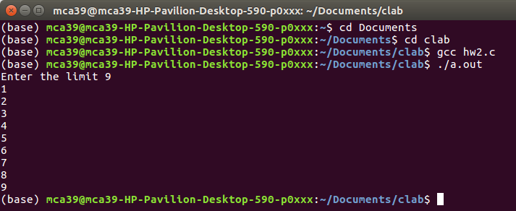

**Q3 Print numbers from 50 to 100 using while loop**

**Code:**

#include<stdio.h>

void main()

{

int i=50;

while(i<=100)

{

printf("%d ",i);

i++;

}

printf("\n");

}

**Output:**



**Q4 Print numbers from1 to n using do while loop**

**Code:**

#include<stdio.h>

void main()

{

int n,i=1;

printf("Enter the limit ");

scanf("%d",&n);

do

{

if(i%2==1)

{

printf("%d\n",i);

}

i++;

}while(i<=n);

}

**Output:**

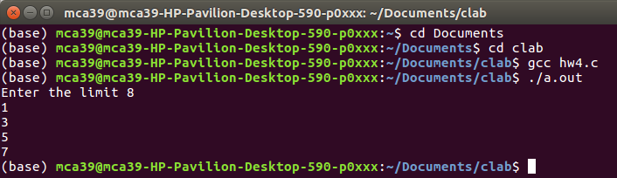

**Q5 find the area of rectangle using function**

**Code:**

#include<stdio.h>

void rectangle(int,int);

void main()

{

int l,b;

printf("Enter the length");

scanf("%d",&l);

printf("Enter the breadth");

scanf("%d",&b);

rectangle(l,b);

}

void rectangle(int a,int c)

{

printf("Area of the rectangle is %d \n",a*c);

}

**Output:**



**Q6 Find the biggest of two numbers using function**

**Code:**

#include<stdio.h>

void biggest(int,int);

void main()

{

int a,b;

printf("Enter the first number");

scanf("%d",&a);

printf("Enter the second number");

scanf("%d",&b);

biggest(a,b);

}

void biggest(int p,int q)

{

if(p>q)

{

printf("%d is the largest number\n",p);

}

else

{

printf("%d is the largest number\n",q);

}

}

**Output:**



**Q7 find the biggest of two numbers using function by returning a value.**

**Code:**

#include<stdio.h>

int biggest(int,int);

void main()

{

int a,b,r;

printf("Enter the first number");

scanf("%d",&a);

printf("Enter the second number");

scanf("%d",&b);

r=biggest(a,b);

printf("%d is the largest number\n",r);

}

int biggest(int p,int q)

{

if(p>q)

{

return(p);

}

else

{

return(q);

}

}

**Output:**



**Q8 find the biggest of three numbers .**

**Code:**

#include<stdio.h>

int biggest(int,int,int);

void main()

{

int a,b,c,d;

printf("Enter the first number");

scanf("%d",&a);

printf("Enter the second number");

scanf("%d",&b);

printf("Enter the third number");

scanf("%d",&c);

d=biggest(a,b,c);

printf("The largest number is %d \n",d);

}

int biggest(int p,int q,int r)

{

if((p>q)&&(p>r))

{

return(p);

}

else if(q>r)

{

return(q);

}

else

{

return(r);

}

}

**Output:**



**Q9 Check if the number is odd or not.**

**Code:**

#include<stdio.h>

void main()

{

int n;

printf("Enter a number");

scanf("%d",&n);

if(n%2==0)

printf("The number is Even\n");

else

printf("The number is Odd\n");

}

**Output:**

